**Variables in Qlik Sense**

**What is a Variable?**

Variables store data (static or calculated) of any type (numbers, string, boolean, float) and get referenced using expressions or directly by using its name.

**What are the methods to create it?**

**Rule 1**: Whenever we create a variable for static value, we prefix variable name with “v”

**Rule 2**: Whenever we store an expression in a variable, we prefix variable name with “e”

After the first character, we should keep relevant names so that it is developer friendly. There are various methods to create a variable. The commonly used are:

**Method 1**: By clicking Variables  in the edit bar when editing a sheet.

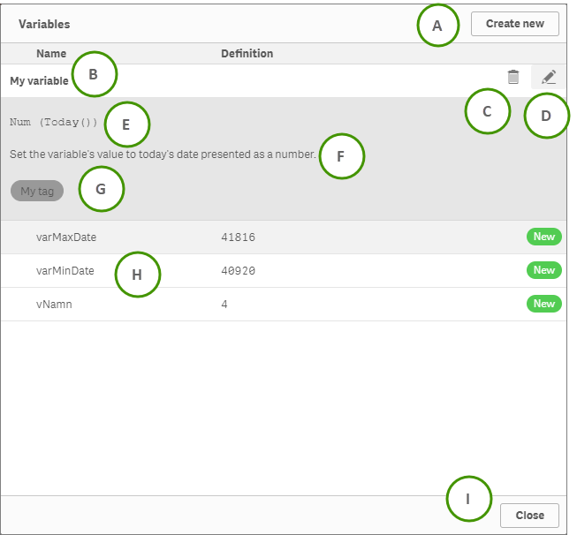

A: Use Create new to create a new variable

B: Click the name of a variable to display its details and show the delete and edit buttons

C: Use Delete to delete the variable. Only possible for variables not defined in the script

D: Use Edit to edit the variable. Only possible for variables not defined in the script

E: Definition of the selected variable. Optional

(<https://help.qlik.com/en-US/sense/February2019/Subsystems/Hub/Content/Sense_Hub/Sheets/variables-dialog.htm>)

**Method 2**: By using **SET** and **LET** statements

Let statement evaluates the expression on the right side of ‘=’ and assigns it to the variable on the left side of ‘=’.

Syntax: Let Variable_Name=Expression;

Example: Let vTest = 5+8;

Set statement to store expression output in a variable, it will store the expression as a value. I’ll show the detailed effect of defining a formula with Let and Set statement in the coming up sections.

Syntax: Set Variable_Name=String;

Example: Set vTest1 = 5+8;

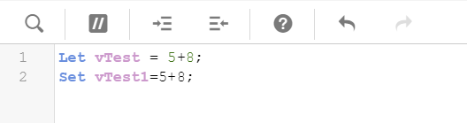

Method1: Create variables in loading script.

**How can we access variable?**

The value of a variable can be accessed using equals (=) sign. If the variable is prefixed with equals ‘ = ‘ sign, QlikSense tries to **evaluate** **the value as a formula** (Qlik Sense expression) and then displays or returns the result rather than the actual formula text.

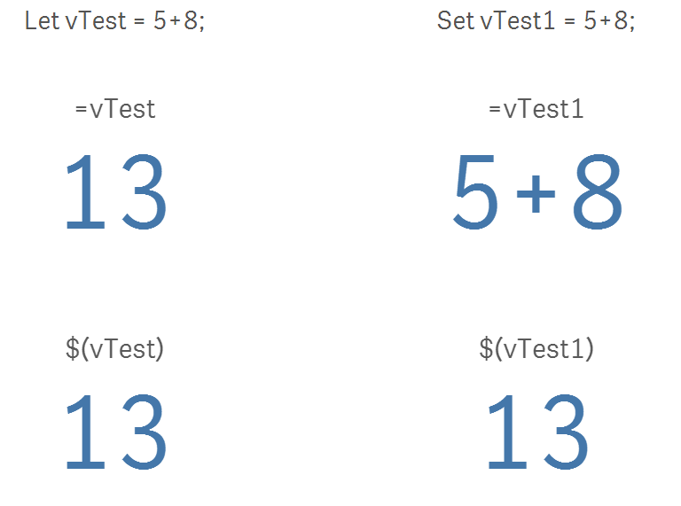

Think about the difference between **LET** and **SET**:

LET: can be dynamic vars

SET: only be string vars

Please notice that, when using ‘=’ to access the variables, the variable (vTest) created using “Let” has got evaluated well. On the contrary, variable (vTest1) created using “Set” has not been evaluated. This is the difference between creating a variable using Set or Let statement.

Also, when using ‘$’ to access the variables, it evaluate variable vTest1 to 13, we can use Dollar Sign Expansion (DSE) to evaluate a formula. Also, this is also a standard way of accessing a variable in QlikSense.

**Trick Here! Read the example below carefully!**

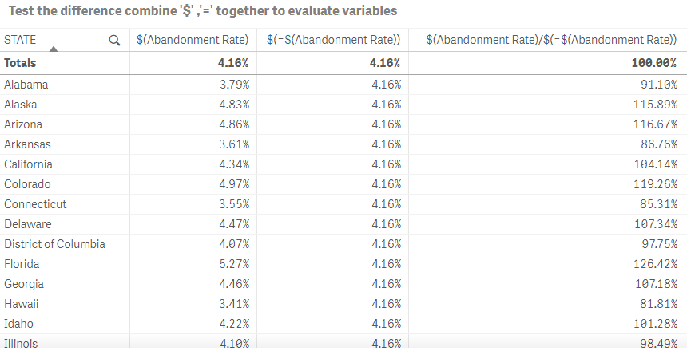

Only calculate overall abandonment rate and not change by dimension

Dynamic change by dimensions

**How to implement? (Please read the example qvf as a reference)**

1. Download and install the [QSVariable](http://branch.qlik.com/#!/project/56728f52d1e497241ae697f8) extension (Combined in Qlik after Feb, 2019)
2. To create a cyclic dimension:

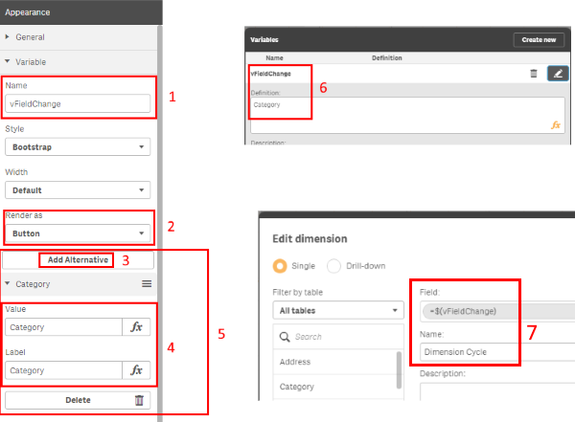

1. Specify a variable name. If you have not already created this variable it will create it in the application.

2. Select Button or Select (dropdown) in the 'Render as' option. You can also experiment with the style and width setting to get different effects.

3. Click 'Add Alternative'

4. Enter in the Value and the Label for the option you want to setup. The 'Value' will be passed into the variable and so this should match your fieldname identically (i.e. case sensitive and use square brackets where there is a space in your fieldname e.g. [Customer Name])

5. Repeat steps 3 and 4 for each additional option you wish to show and switch between.

6. Enter the default value for the variable so that a selection is always made on open.

     a. In the Edit sheet window, click on the following button in the bottom left.

     b. In the Variable window that pops up, click on the edit icon of the variable you wish to update.

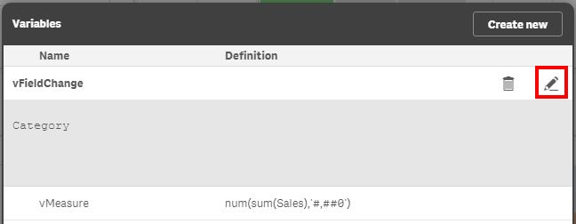

c. Enter the Value that will be the default value for your variable. Ensure that it is one of the values that you have entered in the variable extension object. When done click on the edit button again to save and close the window.

7. Create a dimension in your master items (or reference directly in each chart) using the variable reference as ***$(VariableName)***.

**Reference**

<https://www.analyticsvidhya.com/blog/2015/06/variables-qlikview-data-stories/>

<https://help.qlik.com/en-US/sense/February2019/Subsystems/Hub/Content/Sense_Hub/Sheets/variables-dialog.htm>

<https://community.qlik.com/t5/Qlik-Sense-Enterprise-Documents/Cycle-dimensions-using-a-variable-button-or-dropdown/ta-p/1488404>